Name: _______________________________________ Age: _________ Occupation: _____________________

Current work status (circle):Retired Full-time Part-time Self-employed Unemployed Student Homemaker Off-work

What is the reason for your visit? ________________________________________________________________

How often do you have pain? Constant (76-100%) Frequent (51-75%) Occasionally (26-50%) Intermittently (0-25%)

Are the symptoms changing? (circle) Getting Better Not Changing Getting Worse

Who have you seen for this? (circle) No One MD Chiropractor Physical Therapist Occupational Therapist

What tests have you had? X-Ray Date: _______________ MRI/CT Date: _______________ Other: _______________

Pain Rating Scale: Draw a circle on the pain scale below that best describes your pain at the present time.
NO PAIN | LOW | MEDIUM | HIGH | SEVERE
0 | 1 2 3 | 4 5 6 | 7 8 9 | 10

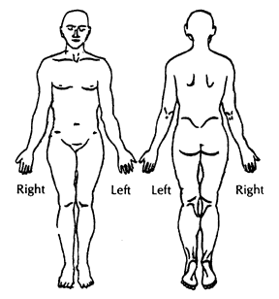

Use the symbols listed below to describe the location and type of pain or unusual feelings you are having by drawing on the Picture(s) above.
OOOO | Pins and Needles
XXXX | Numbness
////// | Pain Sharp/Stabbing
= = = = | Dull Ache/Soreness

